How to use TID
In order to benefit from TID, you need to modify Configuration file to map your Program file to the ID received from TID interface.
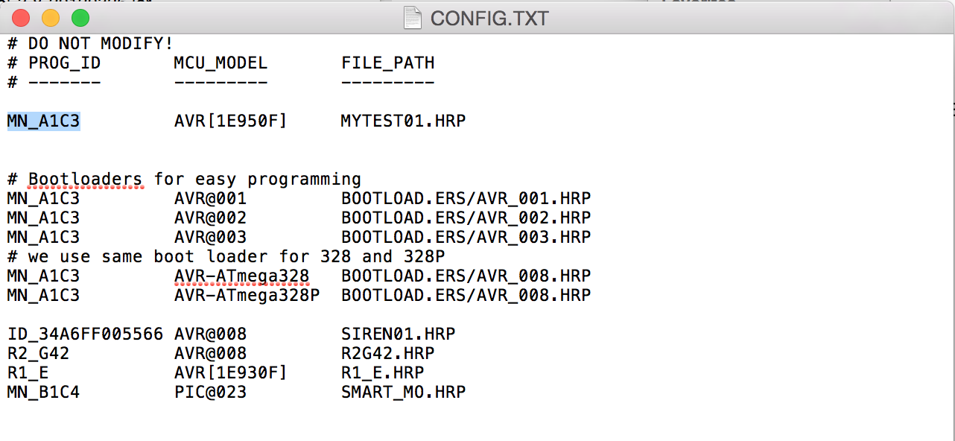
TID supports two identification methods:
- 1-wire ID Tag
- Resistive dividers
Whichever method you use, will result on Target device ID being generated by Programmer.

TIP: To quickly read TID, run BACKUP of your Target board and see TID stored in backup file:
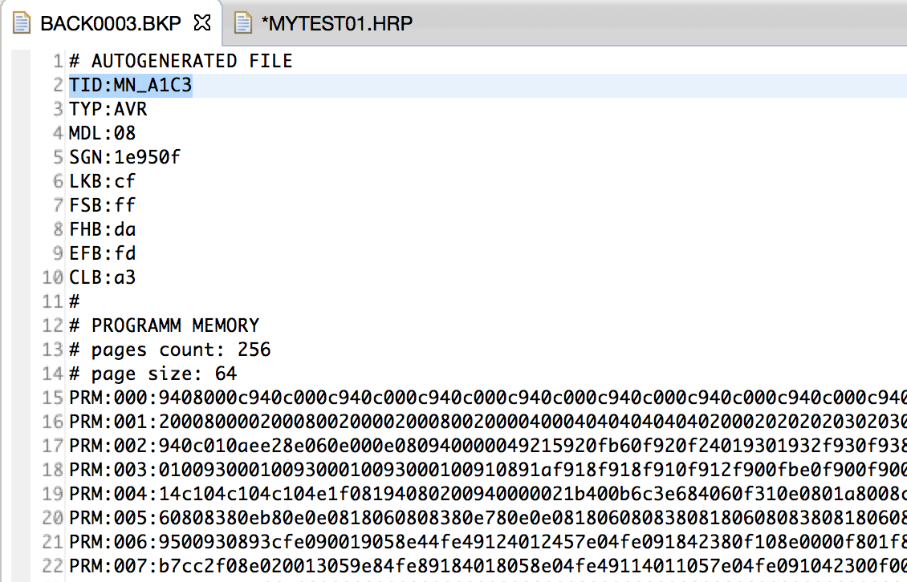

1-wire ID Tag
1-wire ID Tag (DS2401) is connected to GND on ICSP and W0 on TID:
Insert picture here
It generates 48 bits ID, which is then encoded as:
ID_HHHHHHHHHHHH – where HH is a HEX representation of single byte, higher comes first

Resistive Divider R1
Its possible to use single Resistor to identify Target Board ID, for this resistor with nominal value X has to be attached between W0 and GND.
Resistor value | Target Board ID | User defined Name of program (see CONFIG.TXT)
0k | R1_E
1.5k | R1_F
3.3k | R1_G
6.8k | R1_H

Resistive Divider R3
Three resistors are attached to ports W0, W1 and W2, same as for R1
Resistor value W0 | Resistor value W1 | Resistor value W2 | Target Board ID | User defined Name of program (see CONFIG.TXT)
0k | 0k | 0k | R3_E11
0k | 0k | 1.5k | R3_E12
0k | 0k | 3.3k | R3_E13
0k | 0k | 6.8k | R3_E14
0k | 1.5k | 0k | R3_E21
0k | 1.5k | 1.5k | R3_E22
0k | 1.5k | 3.3k | R3_E23
0k | 1.5k | 6.8k | R3_E24
0k | 3.3k | 0k | R3_E31
0k | 3.3k | 1.5k | R3_E32
0k | 3.3k | 3.3k | R3_E33
0k | 3.3k | 6.8k | R3_E34
0k | 6.8k | 0k | R3_E41
0k | 6.8k | 1.5k | R3_E42
0k | 6.8k | 3.3k | R3_E43
0k | 6.8k | 6.8k | R3_E44

